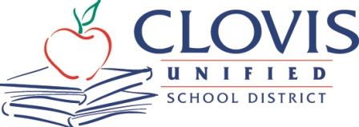
MEDIA ADVISORY
Corrine Folmer, Ed.D., Superintendent
1450 Herndon, Clovis, CA 93611-0599
Oct. 30, 2023
For Immediate Release
Contact: Chief Communication Officer Kelly Avants, APR
Phone: 559-327-9092 Email: kellyavants@cusd.com

Inaugural Native American Student Success Conference to be held by Clovis Unified Nov. 1

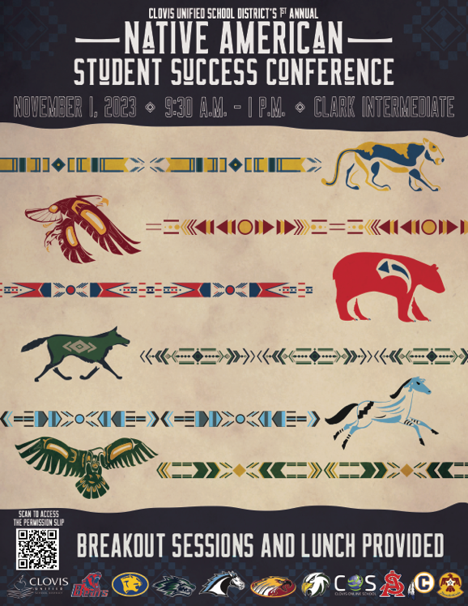
Nearly 100 Native American students from all intermediate and high schools in Clovis Unified School District will attend the district’s inaugural Native American Student Success Conference Nov. 1 at Clark Intermediate School.
The event will open with a traditional ceremonial Native American Song intended to bring healing, brotherhood, and community to the conference proceedings. There will also be a drum circle led by Delaine Bill of the Mono/Wukchumni tribe, who serves as the Cultural Support Specialist for the Fresno American Indian Health Project.
Emmy award winning filmmaker Kenneth Shirley is the keynote speaker for the conference. Shirley is the CEO of Indigenous Enterprise, LLC, a prominent entertainment company dedicated to amplifying indigenous voices and promoting cultural awareness.
Breakout sessions will follow the keynote and be led by local community partners who will be mentors at the conference whose work span the fields of law, cultural advocacy, photography, engineering and the arts.
The conference was created through the efforts of the Clovis Unified Native American Advisory Committee, which is composed of staff, parents and students as a way the district’s Native American students to learn together while celebrating their culture.
“The primary goal of the event is for our Native students to learn about the importance of education, perseverance and goals through a Native lens,” said event organizer Robyn Pellouso Snyder, director of CUSD Supplemental Services.
The conference is planned to become an annual event, joining Clovis Unified’s Asian American, African American and Latino Student Success Conferences that the district hosts throughout the school year.

WHAT: Clovis Unified School District’s Native American Student Success Conference

WHEN: Wednesday, Nov. 1
9:15 a.m. (Multipurpose Room) – Opening Session, Native Cultural Welcome, Keynote Speaker Kenneth Shirley (learn more about the speaker: https://store.indigenousenterprise.com/pages/our-team)
10:15 a.m. (Gym) – Breakout Sessions
Noon (Gym) – Lunch and Closing Session

WHERE: Clark Intermediate School, 902 Fifth St., Clovis

PARTICIPATING SCHOOLS:
Alta Sierra Intermediate, Clark Intermediate, Granite Ridge Intermediate, Kastner Intermediate, Reyburn Intermediate, Buchanan High, Clovis High, Clovis East High, Clovis North High, Clovis West High, Gateway High, Clovis Online School

CONTACT: Clovis Unified event organizers Robyn Snyder, 327-0640, robynpellousosnyder@cusd.com; Saul Salinas, Ed.D., 327-9555, saulsalinas@cusd.com

MEDIA – Those interested in covering the event, please check in with Clark Intermediate main office before heading to the Multipurpose Room or Gym. Organizers recommend the opening session or lunch/closing session as best media opportunities for coverage. Thank you!

