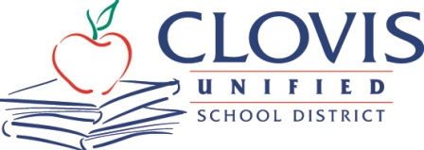
MEDIA ADVISORY
Corrine Folmer, Ed.D., Superintendent
1450 Herndon, Clovis, CA 93611-0599
(559) 327-9000

Nov. 27, 2023
For Immediate Release
Contact: Chief Communication Officer Kelly Avants, APR
Phone: 559-327-9092 Email: kellyavants@cusd.com

Cultural dancing, mentor discussions planned for Asian Student Success Conference
Clovis Unified event set for Wednesday, Nov. 29

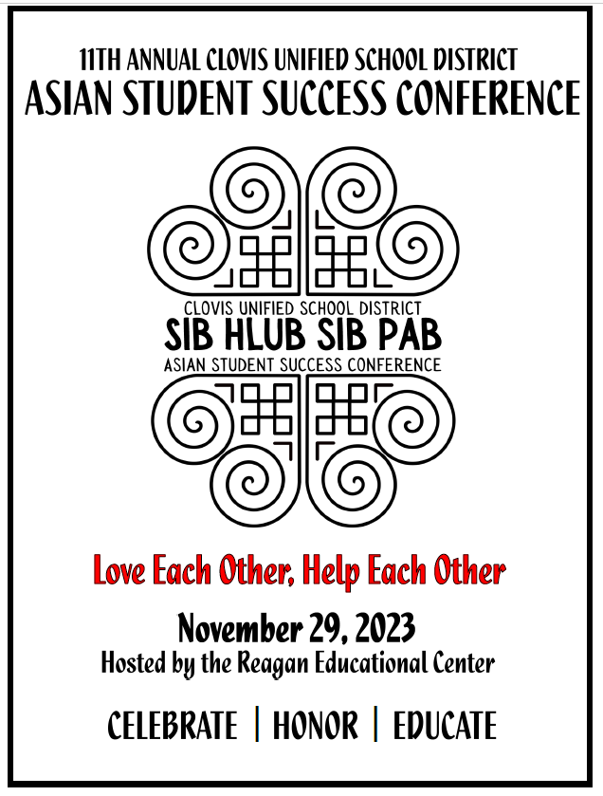
Around 600 Clovis Unified students will gather at the 11th Annual CUSD Asian Student Success Conference at 9:30 a.m. Wednesday, Nov. 29, in the gym at Clovis East High School.

The focus this year will be on the Hmong culture, and the theme is “Sib Hlub, Sib Pab,” which means love each other, help each other. This concept encapsulates the essence of the Hmong community, emphasizing the values of love and assistance, and it reinforces the idea that individuals thrive when they support and care for one another. This cultural concept plays a vital role in shaping social bonds and maintaining a harmonious community life among the Hmong people.

The conference will feature Clovis Mayor Pro Tem Vong Mouanoutoua as the keynote speaker; breakout sessions with local mentors, interactive cultural stations (ball tossing and Hmong dancing) and cultural education on the Hmong secret war; and a closing session that includes traditional dance performances by student groups.

“The conference provides CUSD students with an informative and inspiring day of cultural heritage, resources for academic success, and college and career readiness tools,” said Sonia Torossian, deputy principal of Reagan Educational Center and a part of the planning committee.

About Student Leadership Conferences:
Clovis Unified holds multiple student leadership conferences each year, and the district partners with the community in creating these cultural events where students can learn about themselves and one another.
Upcoming conferences are:
- CUSD Asian Student Success Conference, Nov. 29^{h}, at the Reagan Educational Center
- CUSD Transition Student Conference, Jan. 23, at the Mercedes Edwards Theatre & Clovis Veterans Memorial District. Transition students only.
- Fresno County Superintendent of Schools African American High School Student Leadership Conference, Feb. 6, Fresno Convention Center
- CUSD African American Student Leadership Middle School Conference, Feb. 23, at the Clovis North Educational Center. Open to Central Valley Intermediate Schools.
- CUSD Latino High School Student Success Conference, March 4, Clovis North Educational Center
- CUSD Officer Jesus Ceron Latino Student Success Middle School Conference, March 22, at Kastner Intermediate
Clovis Unified’s leadership conferences are open to all students regardless of race and ethnicity.
“Knowing each other’s culture and diversity is important and can lead to better understanding between students and our community,” CUSD Coordinator of Community Relations Saul Salinas, Ed.D. said. “It’s also vital students learn about paths to success as they consider their futures after high school.”

+++

