MEDIA ADVISORY
Corrine Folmer, Ed.D., Superintendent
1450 Herndon, Clovis, CA 93611-0599
(559) 327-9000

Aug. 11, 2023
For Immediate Release
Contact: Chief Communications Officer Kelly Avants, APR
Phone: 559-327-9092 Email: kellyavants@cusd.com

Clovis Unified staff to kickoff school year
General Session brings 6,000+ employees to Save Mart Center on Aug. 15

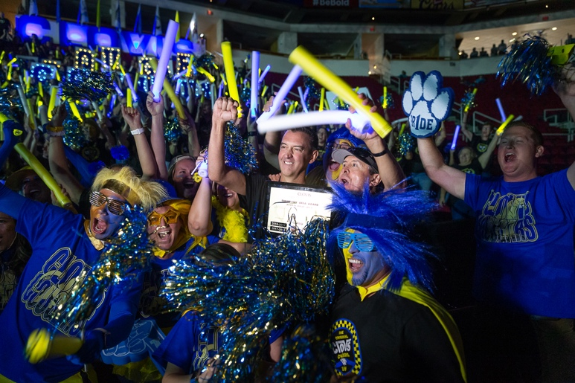
Clovis Unified’s 6,000+ employees will rock the Save Mart Center at General Session, the district’s annual back-to-school rally on Tuesday, Aug. 15. This high-energy kickoff by educators to the 2023-24 school year takes place six days before students fill Clovis Unified’s 52 campuses on Aug. 21.

The excitement will be even higher this year as Corrine Folmer, Ed.D., leads her first General Session after becoming superintendent. She was appointed unanimously by the Clovis Unified Governing Board on March 29, 2023, and assumed the role on July 1.

Having the district’s entire staff under one roof is especially fitting for this year’s theme: “We ARE Clovis UNIFIED!” The spirit behind the theme is one of pride and togetherness, both for the accomplishments of the district and the collective effort of each person that leads to unparalleled levels of student success. Clovis Unified is the 14th largest public school district in California with around 43,000 students.

Dr. Joe Sanfelippo will be the keynote speaker at this year’s celebration. He serves as superintendent of
Fall Creek School District in Fall Creek, Wisconson, and was named the 2019 National Superintendent of the Year by Education Dive. He has authored several books on education leadership, branding and culture, as well as starting the “#1minwalk2work Leadership Challenge,” where he shares knowledge on his 60-second walk from his home to his office across the street.
WHAT: Clovis Unified General Session – Back-to-School Rally

WHO: All CUSD classified and certificated employees

WHEN: 9 to 11 a.m. Tuesday, Aug. 15
(8:30 a.m. Concert by violinist Patrick Contreras)

WHERE: Save Mart Center, 2650 E. Shaw Ave., Fresno

For more information or to arrange an interview at the event, please contact:
CUSD Chief Communications Officer Kelly Avants 559-217-5138 mobile; 559-327-9092 office
Note: On the morning of the event, Kelly will be on the arena floor in front of the stage.

+++

