MEDIA ADVISORY
Corrine Folmer, Ed.D., Superintendent
1450 Herndon, Clovis, CA 93611-0599
Feb. 21, 2024
For Immediate Release
Contact: Chief Communication Officer Kelly Avants, APR
Phone: 559-327-9092 Email: kellyavants@cusd.com

Students to hear uplifting messages from community leaders at African American Student Success Conference
Clovis Unified School District hosts event for area schools Feb. 23
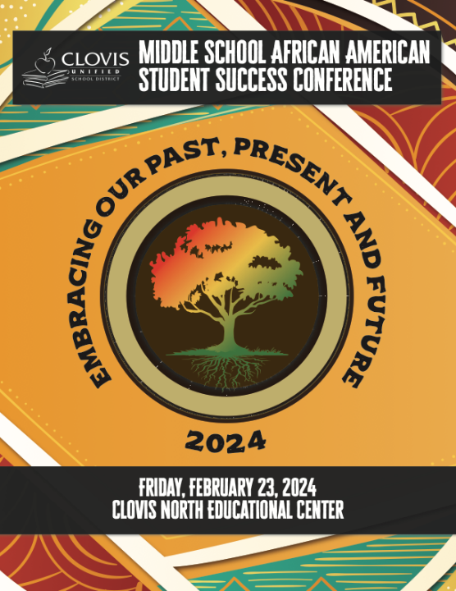
A record number of middle school students representing 32 schools across seven school districts in Fresno County will attend Clovis Unified School District’s Middle School African American Student Success Conference Feb. 23 at the Clovis North Educational Center.

“Embracing Our Past, Present and Future” is the theme of this year’s event. Students will hear the rhythmic sounds of African Drum Interactive as they enter Clovis North’s Performing Arts Center. CBS47 Eyewitness News Morning Weather Anchor Anthony Bailey will deliver the welcome before opening remarks from Clovis Unified Superintendent Corinne Folmer, Ed.D.

Dr. Kent L. Willis, Vice President for Student Affairs and Enrollment Management at California State University, Fresno, is this year’s keynote speaker. His office oversees several student-centered programs and initiatives that include the Office of Black Student Success, Dream Success Center, and the Food Security Project.

Dr. Willis will also lead one of three breakout sessions which all students get to attend. The other sessions will include nearly 50 local professionals serving as mentors. Students can engage in conversation and learn about their careers, which include law enforcement, journalism, business owner, college professor, healthcare and various roles in K-12 education among others.

Clovis Unified hosts the annual event and invites other Fresno County schools to participate.

WHAT: Clovis Unified Middle School African American Student Leadership Conference

WHEN: Friday, Feb. 23
9:15 a.m. – Opening Session and Keynote Speaker Dr. Kent L. Willis, California State University, Fresno; CBS 47 Eyewitness News Morning Weather Anchor Anthony Bailey and Superintendent Corrine Folmer, Ed.D. will also welcome students
10:30-Noon – Breakout Sessions

WHERE: Clovis North Educational Center, CUSD Performing Arts Building
2770 E. International, Ave., Fresno

PARTICIPATING SCHOOLS: Ahwahnee Middle School, Alta Sierra Intermediate School, Baird Middle School, Clark Intermediate School, Clovis Online School, Computech Middle School, Desmond Middle School, Divisadero Middle School, El Capitan Middle School, Fort Miller Middle School, Gaston Middle School, Glacier Point Middle School, Granite Ridge Intermediate School, Green Acres Middle School, Hamilton K-8, Kastner Intermediate School, Kings Canyon Middle School, La Joya Middle School, Martin Luther King Jr. Middle School, Oak Grove Middle School, Reyburn Intermediate School, Ridgeview Middle School, Rio Vista Middle School, Scandinavian Middle School, Sequoia Middle School, Tenaya Middle School, Thomas Jefferson Middle School, Valley Oak Middle School, Washington Academic Middle School, Wawona PK-8, West Fresno Middle School, Yosemite Middle School
CONTACT: Clovis Unified event organizers Alicynne Chaney, 327-5000, alicynnechaney@cusd.com; Stacey Mansfield, 327-5075, staceymansfield@cusd.com

Media – Those interested in covering the event, please check in with Clovis North’s main office before heading to the Performing Arts Center. Thank you!

