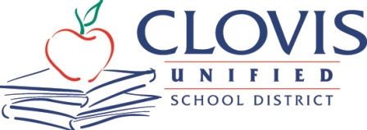
MEDIA ADVISORY
Corrine Folmer, Ed.D., Superintendent
1450 Herndon, Clovis, CA 93611-0599
(559) 327-9000

March 12, 2024
For Immediate Release
Contact: Chief Communication Officer Kelly Avants, APR
Phone: 559-327-9092 Email: kellyavants@cusd.com

Event: Collaborative lesson on the Respiratory System by Clovis East High Patient Care Pathway teacher Kelly Eichmann, PhD, RDN, and Clovis East Anatomy Teacher Jacob Gingold for their respective students
When: Friday, March 15
10:30 a.m. to 12:30 p.m.
Where: Clovis East High School, 2940 N. Leonard Ave., Clovis
Rooms 714 and 716 (Attending media, please check in at the front office first.)
About
Collaborative instruction between two high school teachers will enhance learning with a hands-on interactive lab. Dr. Kelly Eichmann, the CEHS Patient Care Pathway teacher, and Jacob Gingold, the CEHS Anatomy teacher, will work together to connect textbook lessons with a dynamic interactive experience to reinforce student learning. Lab rotations will include: Anatomage Table, Auscultation Simulator, Rescue Breathing, Intubation Simulators, and Bedside Patient Care skills using an incentive spirometer. Also observe how the CEHS Patient Care Pathway students and CEHS Anatomy students are learning from each other.
More:
The Clovis East Patient Care Pathway designed by Dr. Kelly Eichmann includes Medical Careers and Health & Medical Wellness courses. These CTE/ROP courses provide students a hands-on learning experience to Expose, Inform, and Inspire them to consider a career in the medical field.

To Learn More About the CEHS Patient Care Pathway, Visit:
https://www.facebook.com/dremedcareers/

+++

